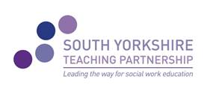

South Yorkshire Teaching Partnership

Monthly Briefing Paper
July 2019
New CPD Brochure 2019-2020
The new social work practice and development CPD Framework booklet was published in May and sent to all managers in adults and children’s across the partnership for managers to nominate their staff to study for accredited modules at both Sheffield Hallam University and the University of Sheffield. Nominations were sent to learning champions in order for us to ensure that the registration process can be completed with the universities in time for induction days in September. The brochure can be found on the SYTP website
http://www.southyorkshireteachingpartnership.co.uk

Social Work Apprenticeships
The University of Sheffield won the contract for the delivery of the Social Work Apprenticeship degree programme and 36 apprentices across the region started in April. Each apprentice has a practice consultant and practice tutor allocated to them throughout the three year degree programme.
Information about social work apprenticeships and future cohorts can be sought from southyorkshireteachingpartnership@sheffield.gov.uk.

Social Work England – new Social Work regulator
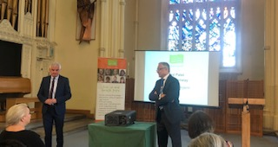 Lord Patel of Bradford and Colum Conway from Social Work England presented at the Children Social Work Matters conference in June and outlined their vision as the new regulators. Social Work England is now based at 1 North Bank, Blonk Street, Sheffield, S3 8JY and has recently announced their launch date as 2nd December 2019 when they will be taking over from HCPC. More information can be found on https://socialworkengland.org.uk/launch-date-announced-for-specialist-social-work-regulator
Masterclasses
Brain Development and Effects of Trauma – Sue Goulding – 16th September (waiting list only)
Theory and Practice in Social Work – Siobhan Maclean – 1st October
The Teaching Partnership is no longer funded by the Department for Education and as part of our income generation plan we are arranging masterclasses for you to attend with a small charge of £50 per place to cover the cost of the key speaker and venue. If there are any topics that you would like us to consider please email Sally.Dean@sheffield.gov.uk.
Celebration and Achievement Event
Our annual event will be held in the Town Hall on 23rd September 2019. Invitations will be sent out shortly. Key external speakers will be Isabelle Trowler, Chief Social Worker Children and Families and Colum Conway, Social Work England. There will be other presentations and workshops. We are currently seeking nominations for Teaching Partnership awards in the following categories:
- ASYE of the year
- Learner / Student of the year
- Social Worker of the year (includes ASWP,IRO,CPC,SWC)
- Manager of the year
- Practice Educator of the year
- Contribution to the Teaching Partnership / Extra Mile Award

These categories will be judged by Principal Social workers across the Partnership and winners and their managers will be invited to attend the event on 23rd September.

To find out more please visit us at www.southyorkshireteachingpartnership.co.uk

To contact us or to sign up for our monthly briefings, email us at southyorkshireteachingpartnership@sheffield.gov.uk

