

South Yorkshire Teaching Partnership

**Monthly Briefing Paper**

|  |
| --- |
| **Issue No10 April 2019** |

**The ‘*Experts by Experience* ‘ Film festival – took place on February 22nd in the Dorothy Flemming Lecture Theatre at the Sheffield Hallam University.**

This was a first of its kind and was attended by over 120 people from across the partnership. It was opened by Sarah Blackmore of Social Work England and attendees watched over 10 films which had been produced by “experts by experience” i.e. local and regional service users and carers. There was also an opportunity to network with each other. Feedback from the event was excellent.

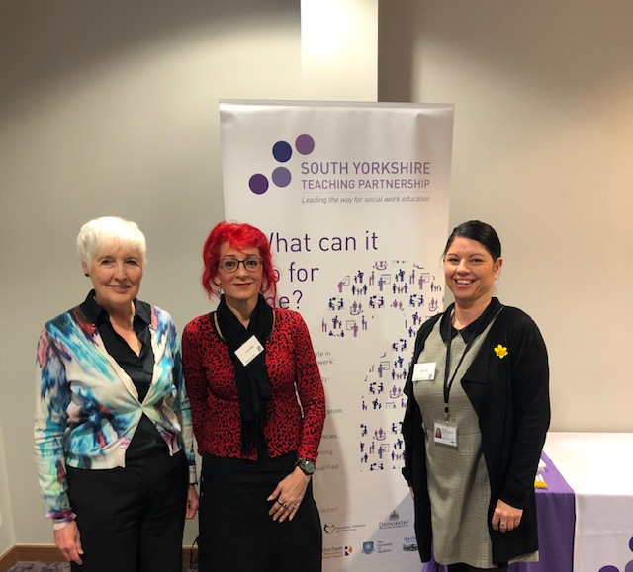

**Partner in Practice – “Working towards Excellence” Conference** Monday March 11th Lincolnshire. Project Manager, Sally Dean, attended this on behalf of the partnership with a stall. Key note speaker included Eileen Munro.

**PG Cert Leadership and Management**

An afternoon ceremony was held at the University of Sheffield on March 8th for the 12 senior staff who had successfully completed the 2018 – 2019 CPD module. Dot Smith, Programme manager, attended on the Teaching Partnership’s behalf.

**Social Work Apprenticeships**

The first 3 year University social work degree apprenticeship has already started at University of Sheffield for Lincolnshire and Sheffield will be joining them in May with 10 children and 2 adult workers.The interviews will be held in April.

**Up Coming Events**

The below Masterclasses will be advertised nearer the time and people will be able to book through Eventbrite:

* 18th June – Masterclass- 'Your social media is my data mine': the how, what, when and when not, of accessing social media information in social work practice" – Allan Norman – Town Hall
* 16th Sept -  Masterclass - Brain Development and effects of traumas – Sue Goulding – Town Hall
* 12th Dec – Masterclass Fuel Poverty – Pete Nelson – Town Hall

September 23 2019 **South Yorkshire Teaching Partnership Event**. Reception Room, Sheffield Town Hall. Further information to follow.

*To find out more please visit* [*www.southyorkshireteachingpartnership.co.uk*](http://www.southyorkshireteachingpartnership.co.uk) or contact us at [*southyorkshireteachingpartnership@sheffield.gov.uk*](mailto:southyorkshireteachingpartnership@sheffield.gov.uk)

For further information, please contact us at [southyorkshireteachingpartnership@sheffield.gov.uk](mailto:southyorkshireteachingpartnership@sheffield.gov.uk) or visit [www.southyorkshireteachingpartnership.co.uk](http://www.southyorkshireteachingpartnership.co.uk)