South Yorkshire Teaching Partnership
Monthly Briefing Paper
Issue No.5 June 2018
Summary
- NEW CPD brochure out now
- SYTP practice consultants now in post
- New SYTP governance structure now in place
- PG Cert in Advanced Adults Social Work now available

SYTP Social Work Practice and Development CPD Framework – our new CPD brochure is now available to download at http://www.southyorkshireteachingpartnership.co.uk/continuing-professional-development/.

SYTP Practice consultant roles
The Teaching Partnership is funding two part time Children’s Practice Consultant posts to work with both our partner universities, giving a practice perspective on the learning experience for students. Lynda Hughes has been working with the University of Sheffield for 2 years, helping to develop their curriculum. Ruth Bastin is now working with Sheffield Hallam University as they develop their new integrated curriculum. Lynda and Ruth are also reviewing the workshops for students whilst on placement, developing a South Yorkshire group to help with preparation for the National Assessment and Accreditation System (N.A.A.S.) and developing ways of helping students to practice interview skills.

New SYTP governance structure
From April 2018, our governance structure is as follows:
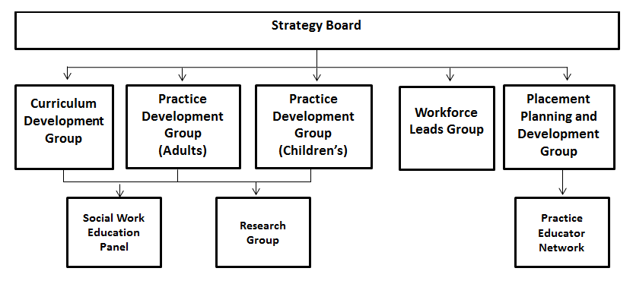

For more information about any of the SYTP groups or subgroups, please contact southyorkshireteachingpartnership@sheffield.gov.uk

PG Cert in Advanced Adults Social Work now available
Sheffield Hallam University are currently developing a Post Graduate Certificate course in Advanced Adult Social Work. This will run from September 2018, and includes the following 15 credit modules: Applied Adult Social Work Law 1 (Care Act); Applied Adult Social Work Law 2 (Mental Health Legislation); Strengths-Based Approaches to Adult Social Work; and Positive Risk-Taking and Advanced Adult Safeguarding. For more details, please see our new CPD brochure for 2018/2019 available at http://www.southyorkshireteachingpartnership.co.uk/continuing-professional-development/.

To find out more please visit us at www.southyorkshireteachingpartnership.co.uk
For further information, please contact us at southyorkshireteachingpartnership@sheffield.gov.uk or visit www.southyorkshireteachingpartnership.co.uk
To contact us or to sign up for our monthly briefings and/or quarterly newsletters, email us at southyorkshireteachingpartnership@sheffield.gov.uk

