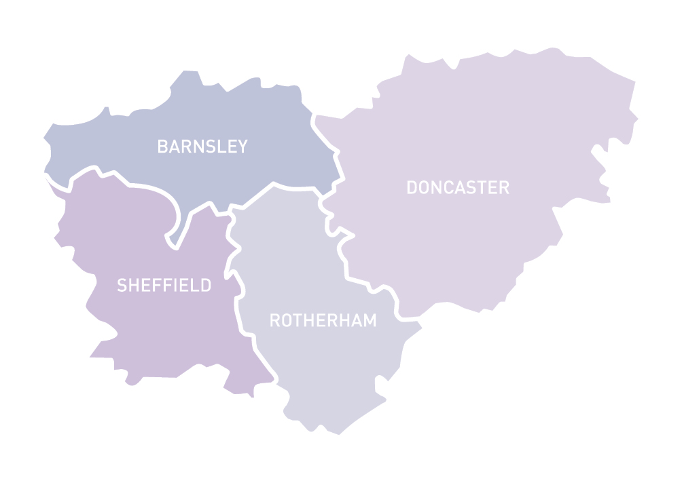

Social Work

Practice Master classes

This series of learning events is provided as part of the South Yorkshire Teaching Partnership, and is aimed at experienced social workers who would like to develop their knowledge in specific areas. The seminars will provide participants with:

• Insights into current practice issues and developments

• Understandings of best practice

• Review of the recent research and the implications for practice

Places are free and this series is aimed at experienced practitioners, with a maximum of 40 participants per seminar. The seminars will be interactive and will provide opportunities to consider your own practice and learning needs.

**November 28th: Restorative practice in social work**

**Venue:** Conference Room 1, The Circle, Rockingham Lane, Sheffield.

**Time:** 10:00am - 12:30pm

This interactive session will consider how social workers in care and protection and domestic violence can use restorative approaches, including family group conferences and restorative meetings. Sharon Inglis runs Circles (a leading RP agency) and is an international expert on the use of restorative approaches. Sharon has worked across the UK supporting LAs seeking to develop this model.

**Places are limited and booking essential. To register, visit:** [http://www.eventbrite.com/e/sytp-social-work-practice-masterclasses-restorative-practice-in-social-work-tickets-28216673831](http://www.eventbrite.com/e/sytp-social-work-practice-masterclasses-restorative-practice-in-social-work-tickets-28216673831?aff=utm_source%3Deb_email%26utm_medium%3Demail%26utm_campaign%3Dnew_event_email&utm_term=eventurl_text)

**December 9, 2016: Working with Families with Complex Needs**

**Venue: St. Mary's Church,** Sheffield.

**Time:** 10:00am - 12:30pm

This interactive session will be led by 'Surviving Safeguarding' and Professor Kate Morris, drawing on research and personal experience it will explore the messages for social work practice. Surviving Safeguarding is a parent led initiative and details can be found at <http://survivingsafeguarding.co.uk>

**Places are limited and booking essential. To register, visit:** [http://www.eventbrite.com/e/sytp-social-work-practice-masterclasses-working-with-families-with-complex-needs-tickets-28216890479](http://www.eventbrite.com/e/sytp-social-work-practice-masterclasses-working-with-families-with-complex-needs-tickets-28216890479?aff=utm_source%3Deb_email%26utm_medium%3Demail%26utm_campaign%3Dnew_event_email&utm_term=eventurl_text)